PSYCHOLOGY UNIT 3 **OUTCOME 1A – VISUAL PRESENTATION**

**Question 1** Complete the following chart to label AND explain the function of each division in the hierarchical organisation of the human nervous system. 8 marks

**NAME: _______________________**

**Question 2a** Martin was just about to fall asleep when he heard a noise outside. This frightened him and therefore activated his Sympathetic Nervous System. Explain three **physiological** changes that Martin may experience. 3 m

________________________________________________________________________________________________________________________________________

**Question 2b** When Martin realised it was only the door slamming in the wind, he started to calm down. **Using terminology of the nervous system involved**, explain how this occurred. 3 m

____________________________________________________________________________________________________________________________________________________________________________________________________________

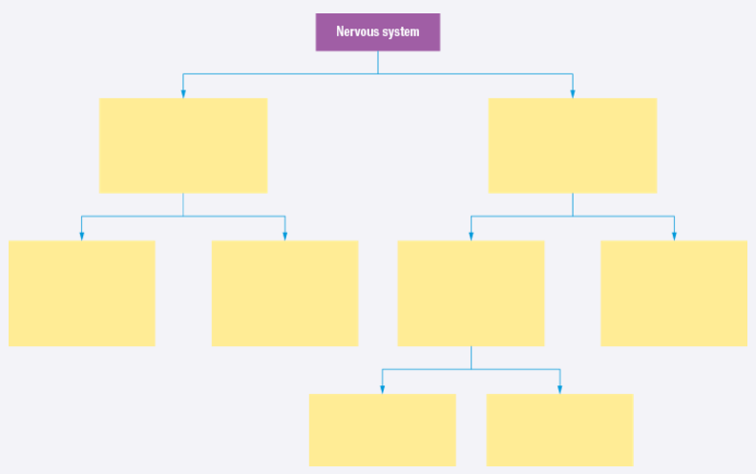

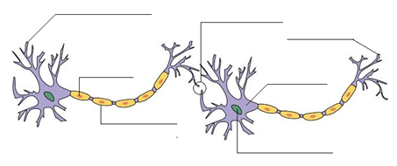

____________________________________________________________________________________________________________________________________________________________________________________________________________________________________________________________________________________________________________________________________________________________________________________________________________

**Question 3a** On the image below, label the

1. soma 2. axon 3. myelin sheath 4. axon terminal 5.terminal button 6. dendrite 7. synapse

8. draw an arrow to indicate the direction of the neural impulse. 8 marks

**Question 3b** **Complete the statement below:**

The image above depicts a typical _ neuron. The other 2 types of neurons include neurons and neurons. Information enters the neuron via the and travels along the . This is covered by a thin protective coating called ______________.

Information then exits via the _____. When neurons communicate with one another, they do so by sending ______________as a ________________ message across the _______________ _______.

Neurons can only travel in one direction, therefore the spinal cord has tracts for (somato)sensory information sent in sensory neurons and _____________ tracts for motor information sent in motor neurons. ½ mark each = 6 marks

**Question 4b** What type of role does a neurotransmitter play in neural **communication** at a synapse? 1 mark

_____________________________________________

**4c Complete the statement below.** 2 marks

‘Some neurotransmitters have an ________________ effect and activate the postsynaptic neuron to fire. An example of this type of neurotransmitter is _________________________.

Other neurotransmitters have an ________________ effect and block postsynaptic neurons from firing. An example of this type of neurotransmitter is ___________________________.

**4d Annotate** the diagram below to outline the neurotransmission process with reference to the **‘lock and key’** model. 3 marks

**Question 4a Label the following features on the diagram below.**

1 .Post synaptic neuron 2. Receptor site 3. Electrical message

4. neurotransmitter 5. Synaptic gap 6. Synapse

7. Pre synaptic neuron 8. Terminal button 8 marks

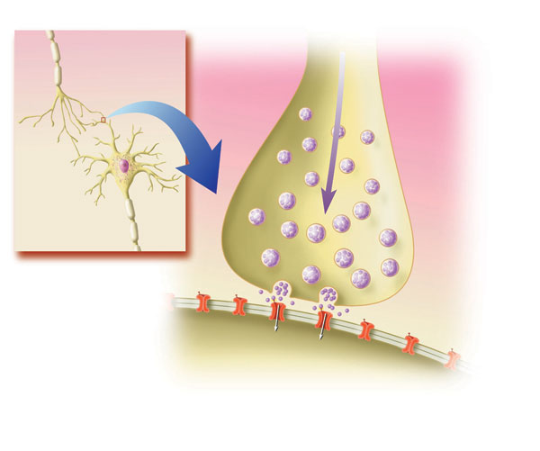

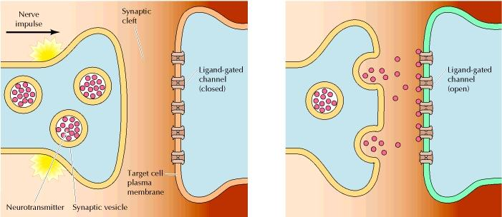

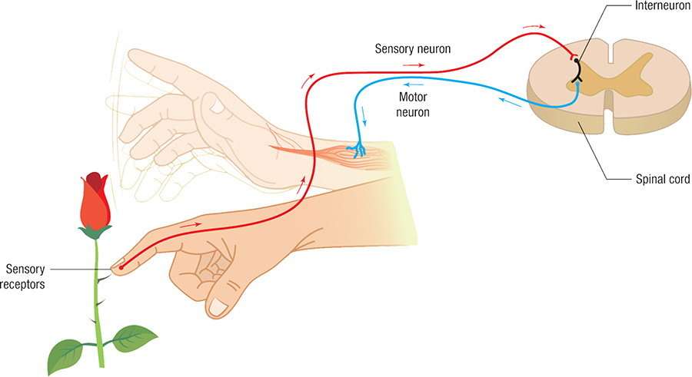

**Question 5**  Examine the image to the right. Identify what it shows and then explain the sequence of the response by using relevant terminology about the **divisions of the nervous system**, the **three** types of **neurons** involved and the role of the **conscious brain** in this response. 8 marks

The diagram shows a _______________________________ ________________________________________________________________________________________________________________________________________________________________________________________________________________________________________________________________________________________________________________________________________________________________________________________________________________________________________________________________________________________________________________________________________________________________________________________________________________________________________________________________________________________________________________________________________________________________________________________________________________________________________________________________________________

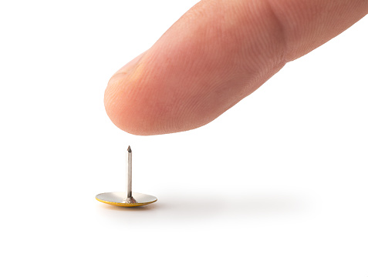

**QUESTION 1 QUESTION 2 QUESTION 3 QUESTION 4 QUESTION 5 TOTAL VCAA MARK**

**/8 /6 /14 /14 /8 /50 /25**

________________________________________________________________________________________________________________________________________________________________________________________________________________________________________________________________________________________________________________________________________________________________________________________________________________________________________________________________________________________________________________________________________________________________________________________________________________________________________________________________________________________________________________________________________________________________________________________________________________________________________________________________________________