The DOZE FAMILY – online activity
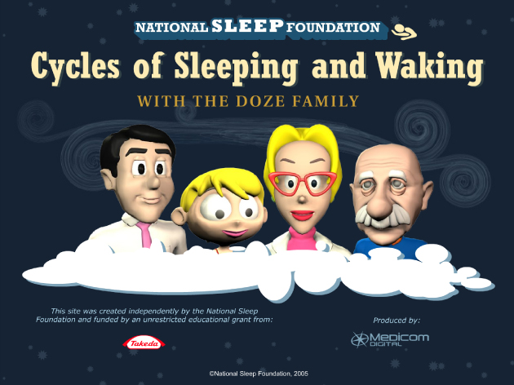

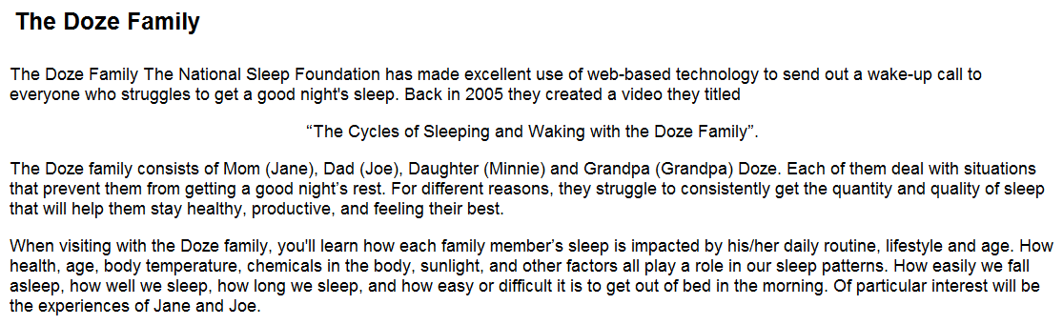
Go to https://www.pimalung.com/dozefamily/doze_family.html

Questions: (in order of animations)
NB. There are two screens on Joes first to explain the animation. Once you get to Minnie then start answering.
Minnie Doze
Q1. How much sleep should Minnie Doze be getting and why?
Q2. What time of the evening is Minnie likely to feel sleepy and go to bed? How does this affect the rest of her sleep?
Q3. What is the difference between Minnie’s biological clock compared to real-time?
Q4. What is Minnie’s body temperature at the moment (when she’s on the computer) in degrees celsius?
Q5. What electrical activity is the EOG, EMG and EEG showing for Minnie? Is this what you would expect?
Q6. What type of brain waves would Minnie have right now?
Joe
Q7. How many hours of sleep is Joe (Dad) having each night? And how is this affecting him?
Q8. How much sleep should Joe be getting?
Grandpa
Q9. Why might Grandpa Doze be having problems sleeping as he gets older?
Q10. When Grandpa Doze naps, what readings doe the EOG, EMG and EEG show?
Q11. What type of brain waves is Grandpa Doze likely to be showing in this early stage of sleep?
Q12. What else is causing Grandpa Doze to fall asleep?
Q13. Is napping normal for older people?
Q14. What is the difference between Grandpa Doze’s biological clock compared to real-time?
Q15. When Grandpa Doze goes to bed, why does he have trouble getting to sleep?
Q16. What else has changed? (Hint look at the right hand panel)
Q17. Grandpa Doze eventually falls asleep but keeps waking up. Why might this be so?
Jane
Q18. Why is Jane (Mum) feeling sleepy?
Q19. How many night shift workers like Jane fall asleep in general?
Q20. When Jane gets home and tries to sleep, why does she have problems falling asleep?
Q21. What can she do to help her fall asleep?
Q22. Click on ‘Learn More’ – how can Jane reset her biological clock?
Q23. Jane eventually falls asleep and then is in REM. What readings do the EOG, EMG and EEG show?
Q24. What else is she likely to experience in REM?
Q25. As Jane has shorter amounts of time to sleep, what affect does this have on her sleep?
Q26. When Jane is on her next shift she drinks coffee. What effect does this have?
Q27. How is caffeine deceptive?
Grandpa
Q28. Grandpa Doze has a drink of alcohol before bed as a ‘nightcap’ to help him fall asleep. What is the immediate effect of alcohol?
Q29. What is the longer term effect of alcohol on sleep?
Q30. What else do you think Grandpa could be doing to help his sleep?
Joe
Q31. Joe has been working late. Why is he having trouble falling asleep?
Q32. Name one of the stress hormones.
Q33. Click on ‘Learn more’. What could Joe do instead before bed to help him sleep?
Minnie
Q34. Minnie is again having difficulty falling asleep. What is the difference between her biological clock and real-time? And what has caused this?
Q35. When her alarm goes off the next day, has her biological clock caught up?

