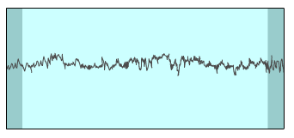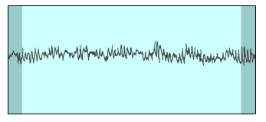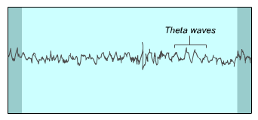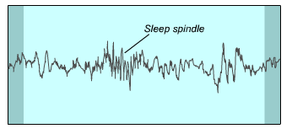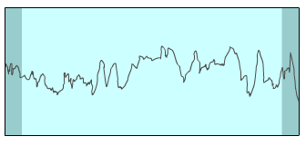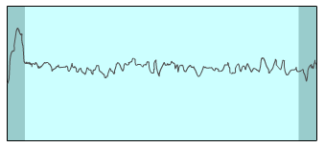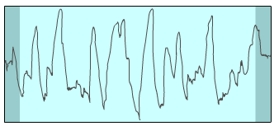

**beta** waves

**alpha** waves

**alpha** progressively being replaced by **theta** waves

**theta** waves + **sleep spindles** & **K complexes**

**theta** waves with progressively more **delta** waves

**delta** waves, more than 50%

**beta** **like** waves +

**saw tooth** waves

**Awake and alert**

**Awake but drowsy or meditating**

**Stage 1 NREM**

**Just about asleep**

**Stage 2 NREM**

**True sleep starts**

**Stage 3 NREM**

**Start of slow wave sleep**

**SWS**

**Stage 4 NREM**

**Very deep sleep**

**REM**

**Active brain but body paralysed**

***K complex***